ACSL
American Computer Science League
2013 - 2014

Contest #4

Junior Division
- Data Structures
List the nodes that are at depth 6 in the binary search tree for :
DENVERCOLORADO

- Data Structures
Given an initially empty stack and the following sequence of operations, what would be the next POPPED element?
PUSH(R), PUSH(O), PUSH(C), PUSH(K), POP(X), POP(X),
PUSH(Y), PUSH(M), POP(X), PUSH(T), PUSH(N), POP(X), POP(X)

3. Digital Electronics Simplify the Boolean expression represented by this circuit.
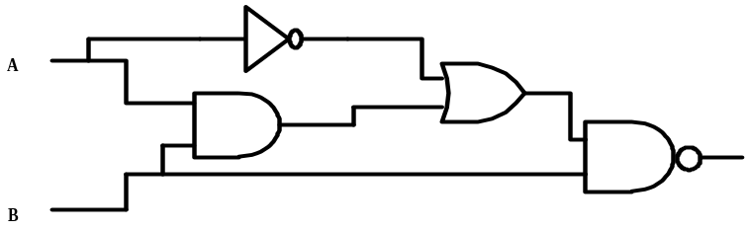

4. Digital Electronics
Translate this circuit
into a Boolean
expression. Do not
simplify.

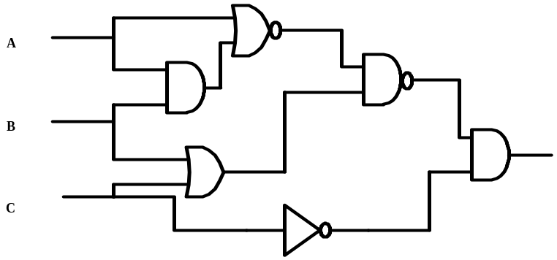

5. What Does this Program Do?
What is printed when this program is run?
b$="": c$="": d$="": e$="":z=0
a$="kitscatssacksandwiveshowmanyaregoingtostives"
for i=1 to len(a$)
if mid$(a$, i,1)="k" or mid$(a$,i,1)>"m" then b$=b$+mid$(a$,i,1)
if mid$(a$, i,1)="i" or mid$(a$,i,1)>"w" then c$=c$+mid$(a$,i,1)
next i
d$=b$+c$
for i = 1 to len(d$)-1
if mid$(d$, i,1) > mid$(d$, i+1 ,1) then e$=e$+mid$(d$, i+1,1)
next i
for i= 1 to len(e$)
if mid$(e$,i,1)="n" then z = z + 1
next i
print z
end

3 | 2 | 4 | 5 | 1
0 | 1 | 3 | 2 | 6
1 | 2 | 1 | 3 | 4

